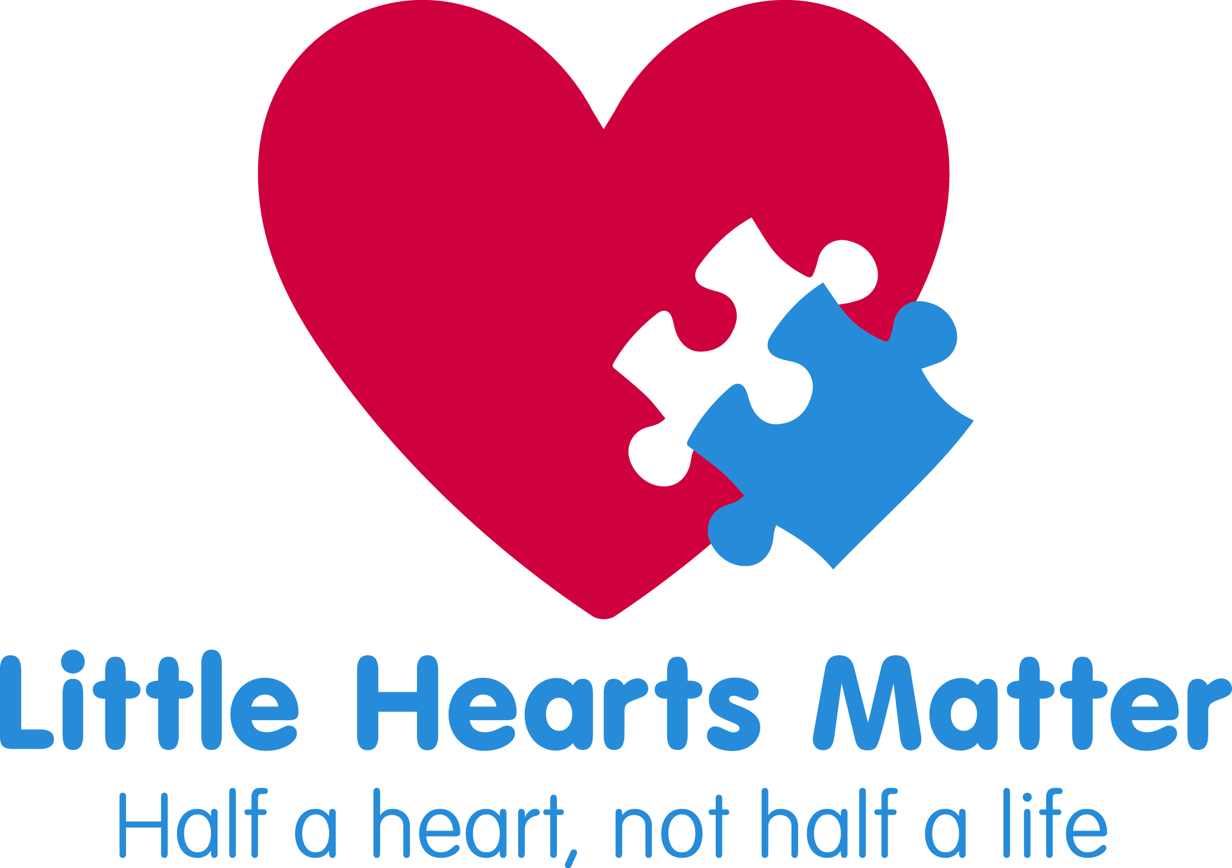

The Independent Review of Children’s Cardiac Services at Bristol Royal Hospital for Children
Over the last two years Eleanor Grey QC and Professor Sir Ian Kennedy have been leading a review into the care and treatment of children with heart conditions at Bristol Children’s Hospital.
The review concentrated on the services and experiences of families between 2010 and 2014. http://www.thebristolreview.co.uk/Bristol-Review--FINAL-REPORT.pdf
A number of areas of concern were raised about the service. Not to the level of the previous inquiry reported in 2001 as outcomes are in line with other children’s heart units but specifically looking at some failures in treatment and care for children between 2010 to 2012.
We have to thank the families who strove to seek answers to failures in care for their children. We hope that the findings in the report acknowledge that the care, especially on Ward 32, at the time of their children’s surgery fell far short of what should have been expected and what their children deserved. We understand that some of the families feel that the report falls short of exploring all aspects of their experience.
“Having listened to the experiences of some of the families treated at Bristol in the early part of 2012 we know that failures in nursing care and the lack of communication between parents and clinical teams caused untold distress. We hope that the conclusions of this Review, whilst unable to bring their children back, will have gone some way, if not completely, to acknowledging their frustrations and concerns and our hearts go out to these brave families for putting their own grieving on hold to improve outcomes for other children. ʺ
Thanks to persistence of these courageous families, further reviews into the Bristol service and the Trust’s recognition of failures, major changes have been made. The CQC review at the end of 2014 found the Trust was now offering a much safer, better staffed and skilled service, within cardiac care but also across the whole Trust.
Throughout the Review report it is clear that the newly introduced Standards of Care for children’s cardiac services and the measurements being set in place to ensure that they are being met are essential in watching for failures in services not only in Bristol but throughout England. We urge NHS England to push forward with establishing all of these nationally agreed Standards as the children, young adults and their families travelling through cardiac services need to rely on their medical team having the skills and resources to give them the best care possible.
“Having been able to take the countrywide experiences of children with the most complex of heart conditions, into the new Standards consultations I hope that their need for better treatment and care, improved communication, reviews of true outcomes (not just survival), joined up community care and bereavement support will improve as hospitals work to build their new services. They must be robustly held to account for the treatment and care of the children and their families. The patient voice is essential in improving and advancing care and must always be acknowledged and listened to.” Suzie Hutchinson

If you have any questions, please contact Little Hearts Matter on: 0121 4558982 or email: info@lhm.org.uk

